Fire stopping and its impact on gas safety – V3
Information Sheet 003 - IGEM Large Business Forum – 30.07.2025

This Information Sheet has been produced by and for LBF IGEM members who are aware it may be distributed to the wider gas community therefore do not accept any form of liability that may arise. Gas businesses and RGE’s must abide by legislation, statutory compliance and industry standards.
When undertaking fire stopping work it’s important to remember that you have legal responsibilities and obligations to ensure your work does not affect the safety of Gas Regulation 8 (1) Existing gas fittings.
Fire stopping work carried out without due consideration to gas safety requirements may compromise the safety of a building and its occupants.

Gas pipework routes
Pipework sleeving
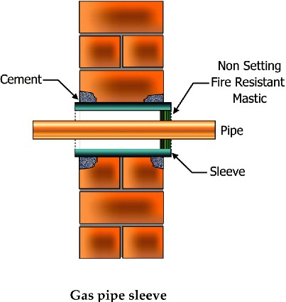
Gas pipework passing through walls, floors and structures must be sleeved.
Sleeving gas pipework protects it from mechanical damage as it passes through a structure and ensures that any potential escape of gas does not lead to an undetected dangerous and potentially explosive build-up of gas within the structure.
In accordance with BS 6891:2015, gas pipework sleeves shall be:
- resistant to corrosion
- impermeable to gas, for example, copper, steel, polyethylene (PE) or polyvinyl chloride (PVC)
- adequate size in dimension and length to pass through full width of the wall
- capable of protecting the pipework from mechanical damage from structural movement
- fixed securely and the outer wall of the sleeve must be sealed to the building structure (a sleeve is often slightly longer than the full width of the wall to allow this sealing between sleeve and wall)
- In the case of catering installations as specified by BS 6173:2020, the sleeve shall protrude 25mm beyond the internal finished surface within the kitchen
- sealed with a suitably fire-resistant flexible sealant in accordance with BSEN1366-3, between the gas pipe and the sleeve (annular space)
- sealed at both ends as specified by IGEM/G/5 Edition3 in multiple occupancy buildings, at one end in other building types.

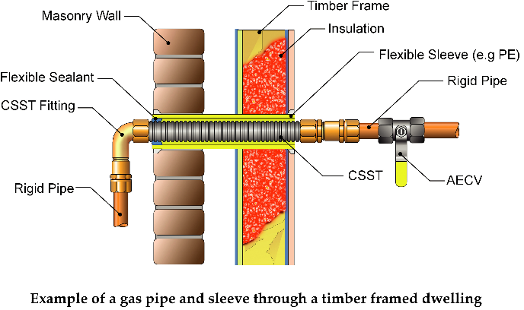
- Before using any product certified against BSEN1366-3 the user is advised to seek confirmation from the product supplier that it is suitable for the intended application.
- The yellow coating which forms part of flexible stainless-steel pipework (CSST) is not accepted as a pipework sleeve and therefore this type of gas pipework must also pass through a dedicated sleeve

Gas pipework in risers
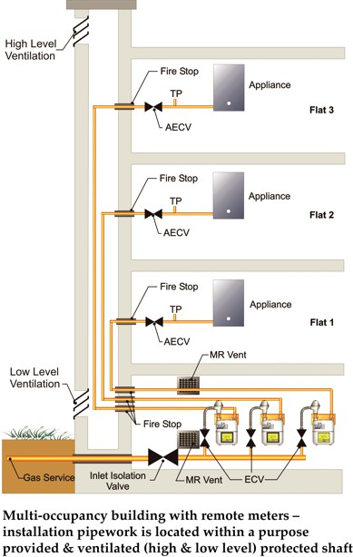
Gas pipework located in High Risk Buildings for example, multiple storey buildings, such as apartments, flats, hospitals, offices etc. will often take a dedicated route, sometimes, with other service pipework and rise through the building, in areas known as risers.
Often these risers form their own protected shaft as described in Building Regulations Approved Document B.
Providing adequate ventilation to gas pipework is imperative to avoid potential explosive atmospheres developing within any service riser.
Blocking or restricting ventilation paths for risers will increase the risk of explosion and fire hazard.
Risers shall:
- be ventilated at high and low level to ensure a continuous air path without impacting on the buildings fire strategy
- be suitably fire rated including any access doors/panels
- ensure access for inspection and future maintenance of gas pipework
- be fire stopped appropriately, gas pipework must be fire stopped and sleeved appropriately at all riser entry and exit points
- not be fire stopped at each floor level within the riser (see note 2).

- Where risers incorporate gas meters, these areas will form a hazardous zone under DSEAR and additional requirements including signage will be required.
- If the building fire strategy requires the riser to be compartmentalised at each floor level, then the riser will require adequate high and low ventilation at each floor level direct to outside air.
- Gas Meter Banks also require adequate ventilation and further controls under DSEAR consult IGEM/G/5.

Summary
If you fail to consider these requirements and your work affects the safety of a gas installation, you not only put people and buildings at risk, but you could face prosecution, a fine or even imprisonment.

Remember:
  - Risk Assess your project before you start work
  - Ensure you are competent to undertake the task
  - STOP WORK if there is a risk of damage to existing gas appliance(s) or pipework – GET ADVICE!
  - Consult with any passive fire product supplier to confirm their products are suitable for the intended application
  - Where necessary employ a Gas Safe registered engineer to decommission and make the installation safe during the project and re-commission the installation once your work is complete.
If in doubt, stop work and contact a suitably qualified Gas Safe registered engineer for advice. To find a Gas Safe registered engineer visit: GasSafeRegister.co.uk.
For Responsible/Accountable Persons seeking further technical guidance and support, contact the Institute of Gas Engineers and Managers: igem.org.uk
IGEM Technical Services IGEM Consultants Directory

Further information and related guidance BSI: bsigroup.com/en-GB/
  - Building Regulations Approved Document B
  - IGEM/G/5 Gas in Multi-Occupancy Buildings
  - IGEM/UP/2 Installation Pipework on Industrial and Commercial Premises
  - BS6891 Specification for the Installation & Maintenance of Low-Pressure Gas Installation Pipework up to 35mm (R11/4) on Premises
  - BS8313 Code of practice for accommodation of building services in ducts
  - BS 6173:2020 Installation and maintenance of gas-fired catering appliances for use in all types of catering establishments (2nd and 3rd family gases) – Specification
  - The Dangerous Substances and Explosive Atmospheres Regulations 2002 (DSEAR)

